Objective: Create an “ICP” and “Buyer Personas” so we can define and target the “Ideal Lead” to generate for our client
First, we develop the ICP, or the “Ideal Customer Profile”. The ICP will be used to define the most profitable market segment (ex. Middle-aged Americans making low-income, looking to pay off credit card/loan debt from 15-100k and struggling to save money), so that we can target the highest ROI segment.
Example ICP:
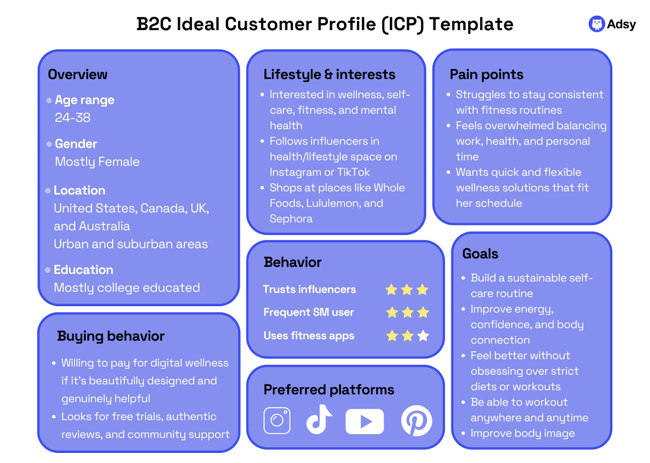
After we develop the ICP, we will develop the Buyer Personas. These are more fleshed out profiles of people from the segment (ex. Jeff is your average American who is motivated to do the right thing, the smart thing when it comes to handling his debt. He isn’t the most financially savvy, but he wants to change that. He wants to do a longer term length to save up money. Or, Sarah, who is a high-income client who lost her job and now is in hardship. She wants to be in and out of debt as quickly as possible). This will help us with more personalized messaging and advertising.

Example Buyer Personas:
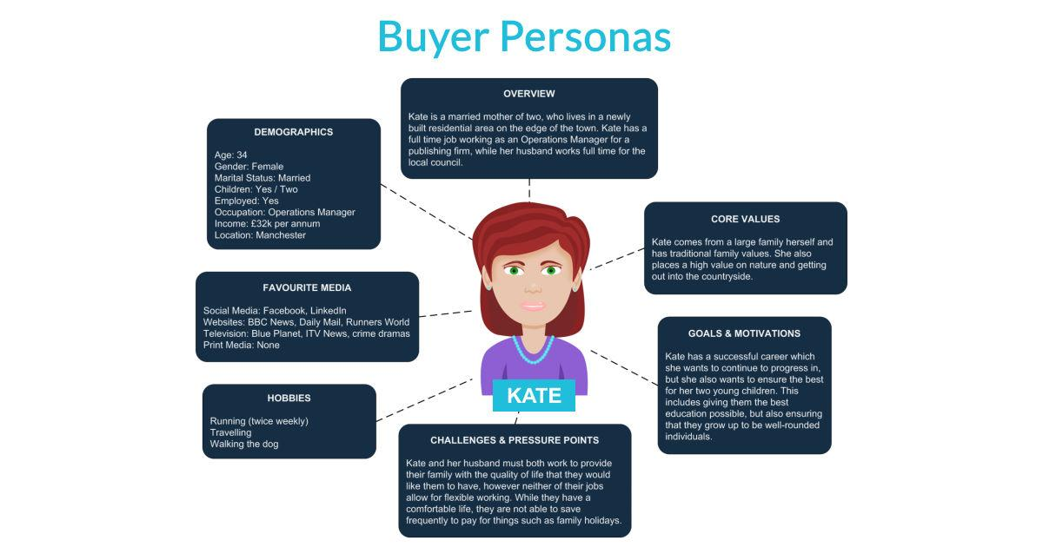
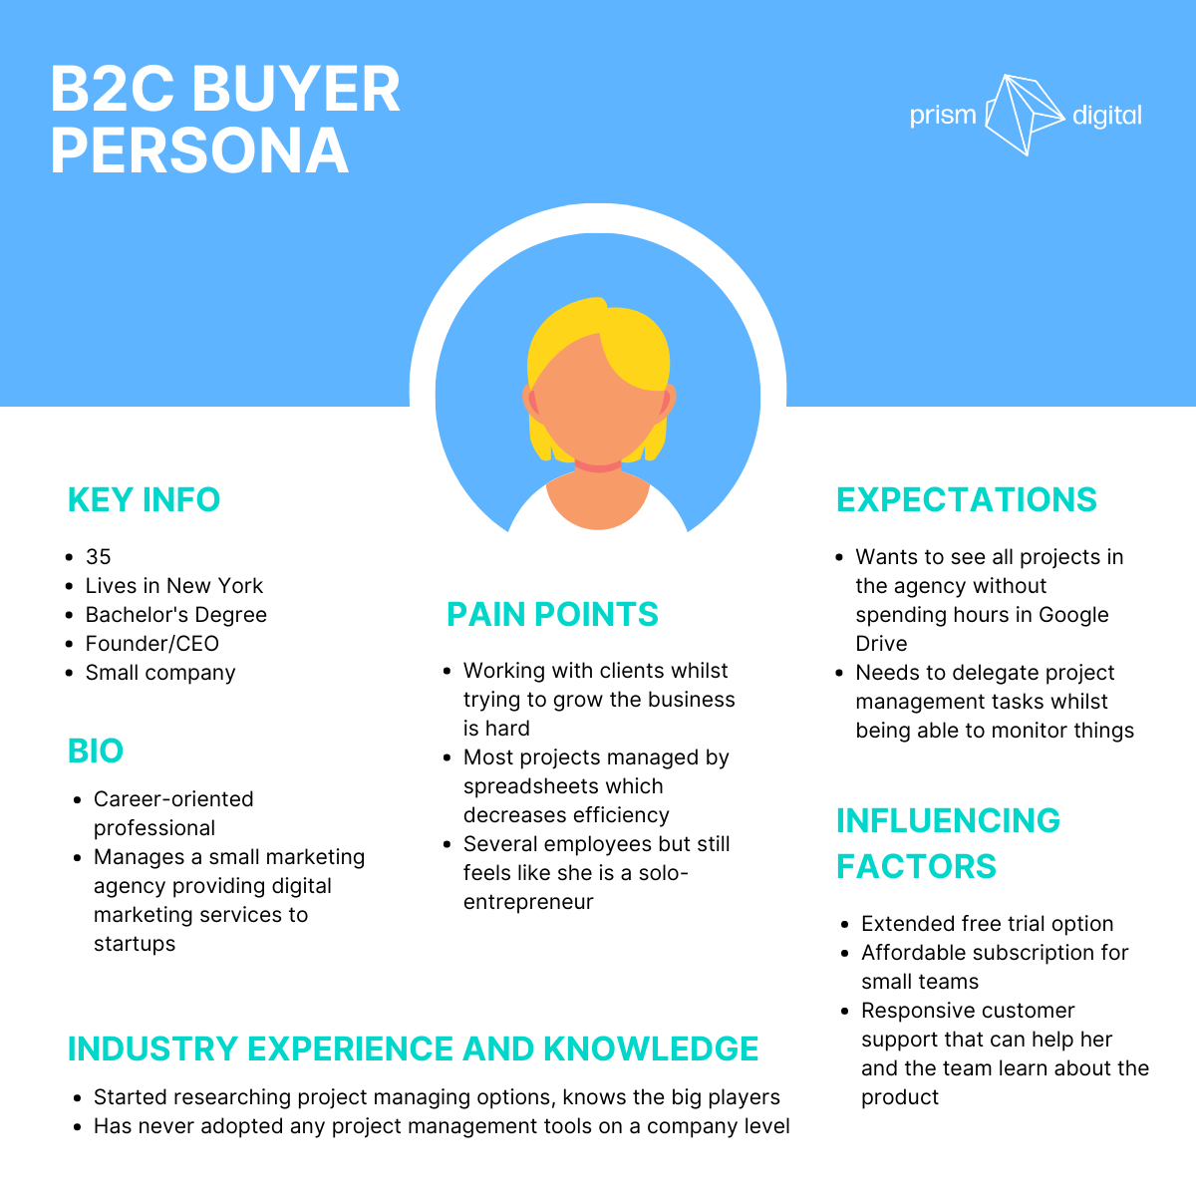

Why Do We Need the ICP and the Buyer Personas?
Once we have defined the ICP and the Buyer Personas, we will understand who the most profitable market segment is and the reasons behind their decision-making (or the why). We will have insight into the people who have the most intent to close. This will allow us to optimize our marketing strategy by speaking to these people only – for now.
When we accumulate leads, we will be able to use these models to qualify them and eventually score the leads. We want to really focus our attention on quality, not volume. We want to hand off only high-scoring leads to our sales team.
Remember, the ICP and the Buyer Personas can change – they will likely change in the long-term as Gen Z and Millennials age and become the target market. They are also living in even worse economic conditions than their previous generations, so there is opportunity for those segments to explode. If we slowly invest in them now, we can see the early signals that define those segments and be ahead of the curve.
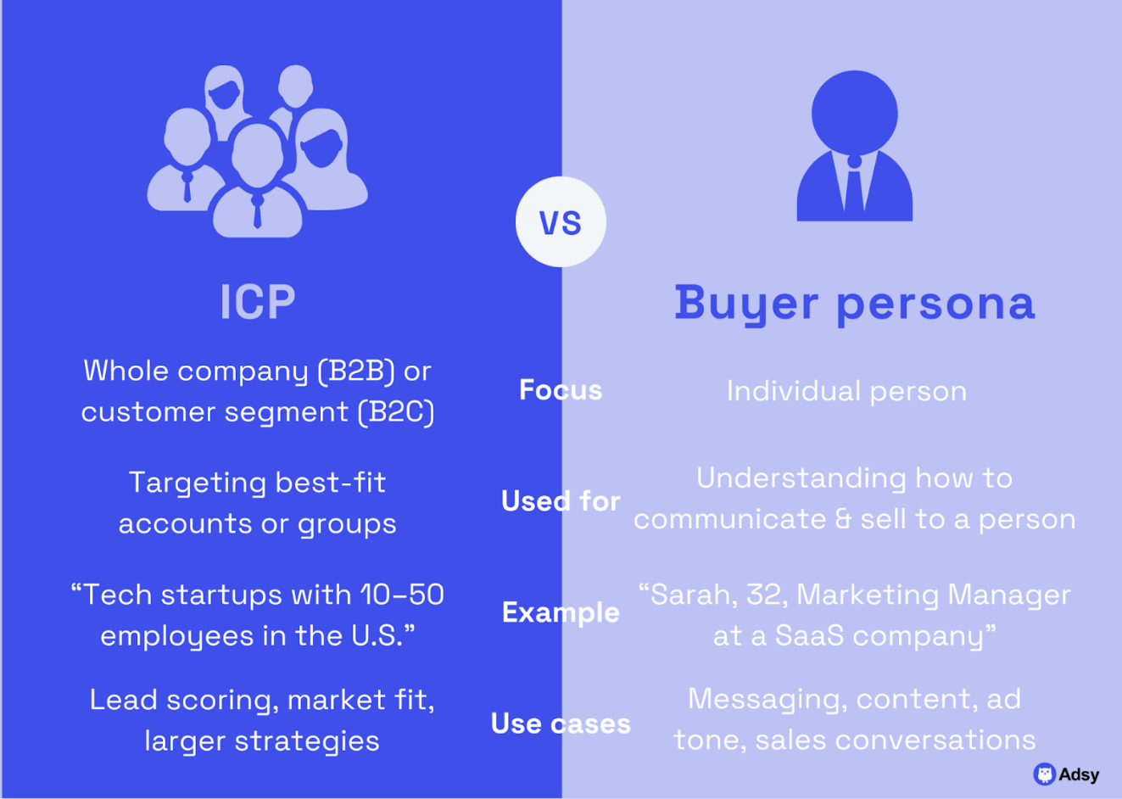

Building the Ideal Customer Profile -> The Context
  - To understand the customer, we must understand the circumstances surrounding them: the broader context or situation that tells us why they are struggling. Most people have a specific reason that they fell behind or got caught up in debt. They typically include:
    - Medical emergency
    - Unexpected expenses – car repair, home repair, death in family, sickness, insurance rates went up, etc.
    - Loss of income – they lost their job, can’t get enough hours/shifts at work, maybe had to take a job elsewhere that pays less
    - Interest rates spiked on them – their monthly payments went up because their credit card company started charging more interest. Now, they can’t get ahead.
    - Divorce – very costly, got into debt to pay legal fees
    - Cost of living - this pretty much applies to everyone. Costs went up, income didn’t.
  - We need the reason to empathize with the client and tell a story (this falls more on the sales team but still important to understand). But the reality is that a lot of times these people are careless, uneducated about finance, and irresponsible. Other times, the case is extreme, and maybe someone had cancer and had no other choice. Or they lost a loved one. Or they were laid off from a company after decades and they don’t know how to do anything else. The situation was completely out of control. Regardless of the reason, we want to empathize with them and make them feel heard. This will help shape our voice in the content we produce.
  - Then, there is a broader context that applies to basically everyone. This is the current state of the world. This is high inflation across the board that is squeezing everybody. This is the uncertainty that people feel in the economy. This is the loss of hope. Although this isn’t specific, it does help us tell a broader story in the absence of a unique circumstance. Remember, even though this is a broad story, everyone may experience it much differently. One may experience it through having to trade down on certain items in the grocery store and one may experience it by not taking a vacation or not having as much in savings as they would like. Someone else may be struggling to put their kids in college. Always think of it from their perspective. The story is everything.
  - The main context is that they are struggling. These people do not make wise choices. They are in bad situations. Usually, there is something negative that led to this. Their debt is a symptom of their life. These are not prudent people. They are not typically forward thinking. We want to change that. We want to turn them into the perception of a prudent, forward-thinking, savvy individual. We want to show them what it is like if their situation changes (from negative to positive). This creates urgency, and ultimately intent.

Building the Ideal Customer Profile -> The Variables
This is a broad segment of the market. It is used for targeting.
- Demographics
  - Race/ethnicity
    - The customer’s race is poor. They are typically midwestern white people, but they are certainly not limited. They are many times Hispanic, Black, and sometimes Asian.
  - Age
    - The debt settlement customer is typically older. They may be in their late 30s, 40s, 50s, 60s, and above. (There is an opportunity, however, to target Gen Z and Millennials on TikTok since they are also accumulating a lot of debt and living under harsh economic conditions)
  - Gender
    - The customer’s gender is generally split evenly between men and women. I wouldn’t say one gender dominates another.
  - Education Level
    - I’d say the education level does not really matter anymore because college is so mainstream. I think the younger people tend to be college educated more than the older people.
  - Occupation(s)
    - The college-educated could be in very high professions as well like doctors, lawyers, engineers, etc. They have debt too! No need to discriminate. But the majority of the customers probably don’t have a very high education level. They work in blue-collar or low-income fields, such as truck drivers, teachers, retail space, customer service, construction, food service, nurses, janitors, or simply living off welfare. They don’t typically have exceptional, or well-paying jobs. Many work multiple jobs, such as a mix of retail services, uber, or restaurants. Some are tradespeople or small business owners – these people are typically more on the stubborn side.
  - Income
    - The customer is typically low-income. They make around $50,000 on average. But more importantly, their debt-to-income ratio is very high, above average. In other words, the ratio of money they have coming in versus the money they have going out to pay debt is very high. This creates little breathing room in their monthly budgets. Their total credit card/personal loan debt averages around $25,000 - $30,000 (this excludes car loans, mortgages, student loans, but these still impact DTI)
  - Living situation – rent or own?
    - I’d say most of the consumers tend to be renters. I think it is easier to pitch homeowners because they already used their credit for the thing they needed most for (a home). I did hear a lot of objections from renters who wanted to save for a house in the future (this is a valid concern).
  - Location
    - The customer can be from any state across the country, but they come from rural areas. They live in small towns. They typically live in places where they are required to drive to work, to get groceries, etc. They live in poor neighborhoods, sometimes in big cities like New York, Los Angeles, Atlanta, Charlotte, Cleveland, or Denver. They are impoverished. They are your everyday American who lives paycheck to paycheck.
  - Marital status
    - The customer typically is married, and many times has children. If not, they may have a partner or in some cases (maybe if they are very old), they are alone. I think family tends to mean more expenses and higher DTI and thus higher likelihood to close.
- Debt Size
  - The sweet spot (from Schneider) is between 25k-65k. Too little and it doesn’t make a ton of sense and too large, they may go bankrupt or try to get settlements on their own. (From Schneider) – we don’t need to put a restraint on income (and because there is no income verification some people tend to lie), but people that have an income of 30-100k would be ideal relative to the 25k-65k debt size.
- Credit Score
  - Similar to debt size and income, there is also a sweet spot for credit scores. Too high and they are protective of the score; in denial of the negative effects they are experiencing. Too low, and the people have no intent to actually pay off their debt. The sweet spot for credit scores tends to be in the range of 500-620.
- Credit mix
  - How many accounts do they have? What’s the breakdown? It is ideal to have people with 5-10, or more, credit cards since they don’t have to close all of them. It is also ideal to have people who just have loans, since they don’t risk losing access to credit. We want to avoid car loans, student loans, mortgages, and secured loans since we cannot work on them. The debt must be unsecured.
- Needs and Goals
  - Save money - by cutting monthly payments and cutting the total payback down (ideally both)
  - Save on interest - CUT INTEREST DOWN
  - Accelerate their path towards being debt free (take 4 years instead of 10+)
  - CONSOLIDATE - get it all in one payment for organization and efficiency (many have so many accounts that they pay manually)
  - Future purchases like homes, cars, etc.
  - Many want to repair credit but don’t understand that they will need to be debt free first
  - People looking to grow savings - retirement, investments, personal, emergency fund
  - People looking to depend less on credit cards - need them to make it through the month, but stuck in cycle
  - Overall, we want to change them from being someone who is defined by debt to someone who has choices - this is a lifestyle change and perspective change. Improve overall financial health and have a PLAN
- Pain Points
  - Remember, at the end of the day, these customers are in debt. Debt is an emotional burden. It leads to a myriad of other problems and consequences. Understanding the pain points of the customer is arguably the most important, and sensitive, part of the sale. Again, this is on the sales rep to lean in on these pain points, but it will help us market the product better if we can understand what the customer is going through. Sometimes, the customer knows his or her pain points. Other times, they may have no idea. A lot of the time, they know, but they don’t know the extent of it or they are not ready to admit it to themselves. Salespeople want customers to realize these pain points, so that the customer can feel an emotional shift internally. This change in emotion is ultimately what leads to conversion. This change in emotion will create urgency and then intent.
  - One significant pain point is cash flow. These people are typically making the minimum payment. They can’t afford to pay above the minimum payment and usually can’t afford the minimum payments either. They operate in the negative, month after month. This is how the debt accumulates. Many don’t realize how quickly it can build up with interest. Making the minimum payment effectively does nothing. That is the sweet spot that creditors want their customers to be in. That is the bread and butter for credit card companies. Many have been paying minimum payments for years, not realizing how much money is being wasted. And still, they cannot save money at all. Most of them have virtually nothing saved up. Cash flow is what hurts the most. It’s what they feel every day. Tight cash flow means trading down in many aspects of life. It means not having emergency savings, not having retirement savings, not having investments, not having spending money, not having money for a home, not having money for a vacation, etc. Put yourself in their shoes. Imagine that every dollar you worked for goes to pay a bill – and you are still in debt! All while these credit card companies continue to drain them, making it nearly impossible to pay above the minimum payment. The sales rep must make them realize this reality. This is how they create urgency.
    - Whenever you think of a pain point, always ask yourself so what? What does not saving money mean? It means not having a home for your family. It means not spending money on the people you care. It means not having a stable investment or retirement account to fall back on. It means having no Plan B. It means stress and uncertainty. It means being in an embarrassing situation where you may require help from a family or friend. It means making the situation worse if you don’t fix it.
  - Another significant pain point is high interest rates. Many of these people do not realize the sheer insanity in paying 20-30% interest rates. They don’t realize the harm it causes to their financial stability. Probing understanding their interest rates will also create an urgency. No matter how we slice it, paying obscenely high interest rates cannot be a wise decision. Lighting money on fire would be a better investment because then you would at least be warm. Paying high interest rates is a trap that they must understand, regardless of how they got there. The sales rep will often show the customer how much they are projected to spend on interest in a given period by using an interest calculator. These amounts can be scary, and often equivalent to a down payment on a house. Sales reps often show the customer what their current path is by doing what they are doing now versus what their path could be by making a change. We must urge them to change.
  - Another significant pain point is having low credit. Surprisingly, these people are obsessive about their credit. I think this may have changed a little bit over the past few years, but they are very protective over credit. If it is good, they want to keep it good and if it is bad, they want to fix it. If they don’t, you need to create some kind of urgency or use a different angle.
  - Another pain point is having payments all over the place. Some people have 20+ accounts, many are paying manually. They can’t keep track and don’t even know about some accounts that are open. One location. One payment. That is what they seek.
  - Overall financial stress
  - Not seeing any progress whatsoever - debt won’t go down - it is staying the same or increasing
  - High utilization rate, high DTI, low credit -> all reasons they are not getting approved for a loan
    - Can’t get approved for a loan is a pain point. Get can’t approved for anything so their only options really are to take a risk with a professional company or take the risk of what they are doing now
- Where do these people live online?
  - These customer segments tend to use facebook and instagram for regular consumption and research. Additionally, they use google to research debt relief, debt relief companies, and debt relief customer experiences.
  - Youtube may become a space too that is good for long-format educational videos or podcast styles. Seems there is a lot of potential there and for Tik Tok too as younger people are entering the market segment.
- Buying behavior
  - These people do listen to podcasts (like Dave Ramsey, he really did a number).
  - They go online and search reddit forums, facebook, instagram, Google, and many digital sources to find real stories on settlement.
    - They look for authentic views and community support always when researching companies
  - They do not want something overly complex - they want a trusted partner who they can count on is going to take care of them. This trusted partner is like a protector, or a defender, that will shield them from all the negatives of the program. They are looking for confidence. They are looking for professionalism and integrity. They are looking for clarity, reassurance, and most importantly, empathy.
  - They don’t use technology like they should - they don’t really use budgeting tools or things like that to help them keep monthly expenses down. They are many times oblivious to these helpful tools and resources.
  - They want an understanding friend. After all, everyone is judging them based on their credit except for you. You need to be friendly but authoritative, and demonstrate that through superior knowledge.
  - Looks for low fees and low monthly payments obviously. They want to know they are not paying for the service before they see results, which is HUGE in this industry

Building the Buyer Persona -> The Variables
Buyer Personas are used for tailored messaging
- Personality traits
  - These people are down bad. They are stressed out! Debt is usually just one small part of the big picture. Something else bad probably happened to them (losing a job, death in the family, forced to move, etc.). They are NOT in a good mood. Many are depressed, anxious, and afraid.
  - They are protective and very cautious. They are stand-offish at first until you empathize and get to know them. Then they can be super friendly and your best friend.
  - They are more down to earth when you do get to know them. They are your everyday Americans. Think the Midwesterners.
- Fears
  - These people are afraid of the program not working. There are no guarantees but we have to show them it is the best option given where they are at and show the track record of successful settlements and give insights where it matters.
  - They are afraid of scams. They see a ton of shady companies in this industry and just want a straight answer.
  - They are afraid of taking a big step (which it is). They want to be reassured that the human they are speaking to on the other side will be for them no matter what. And they will be.
- Objections
  - The most common pain point is credit score and credit impact. This program will undoubtedly harm the customer’s credit score significantly in the beginning. As they progress through the program and begin paying off settlements, their credit score should rebound. These consumers typically have a toxic relationship with their credit cards. These credit cards, despite being incredibly expensive and often predatory, have helped them through difficult times. They probably have used credit cards to pay grocery bills, utilities, things for their children or partners, etc. They have an emotional attachment to their credit cards. It is the job of the sales rep to make them realize the pain that the credit cards are causing now, and to give them hope that they be in a much better financial situation than they are in now, with the help of the program.
  - Another big one is creditor calls. They don’t want to be harassed or be made to feel like they are doing something morally wrong. They want to do the right thing, sometimes, or at least feel like they are not disrupting the peace.
  - They don’t want to close cards! They love these damn things. Again, they often have a dependent relationship with credit cards and are very reluctant to let go of them.
  - They don’t want legal trouble. We got that covered and it is rare.
  - They don’t want to miss payments. This may be the toughest thing to overcome, but it goes hand in hand with credit impact. It will get better.
- Lifestyle and interests
  - These people live a pretty modest lifestyle where they cannot afford to do anything. So many people have complained to me they can’t afford to go out to eat, they can’t afford vacation, they save no money. The higher-income people tend to be the opposite - they tend to be living way over their means and are leasing cars and paying for vacations they cannot afford. These people are a little more difficult to deal with because they are in denial.
  - NDR was recently sponsored by Nascar. These people like to drink. They like to go on vacation. They know they are in a tough spot and they just want to enjoy what little time and what little money they have. This could be a great angle when it comes to messaging. For example, we could bring an advertisement around
- Behaviors
- Buying motivations

- Desires
- Beliefs
- Struggles
- Decision-making process
  - These customers need to feel like they are saving a significant amount of money, either month over month or in total savings (ideally both).
  - These customers need to feel like they are making a financially wise choice. They are doing a cost-benefit analysis (what is the tradeoff between closing some credit lines and hurting my score vs. saving real money and being debt free?)
  - The customer needs to feel like the timing is right - it aligns with their plans to save for retirement, buy a home, buy a car, pay off other things like their mortgage, etc. Align this plan with their broader financial plans.
  - These customers need to feel an intense level of trust and integrity for the company and salesperson they are working with. They will look at BBB reviews, Google reviews, social media, etc. They will also ask their friends, family, and anyone for advice as well.
  - They need to feel like they still have some control. Like it is on their terms. You are the expert that is ultimately guiding them, but they need to feel confident in the decision and that they are making a choice to regain control in their life.

Now that we have the ICP, what is an example of an ideal lead?
- Person who is making the minimum payment for now but can feel they are going to fall behind soon if they do not make a change. Even if they are still exploring alternative options (like HELOCs or borrowing money), they are very likely to close compared to someone paying the minimums or above comfortably.

